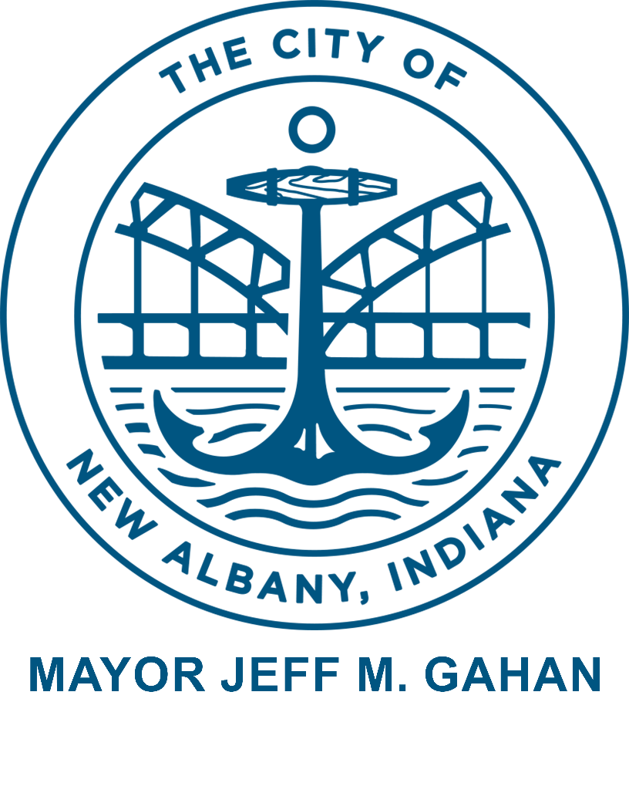

CITY of NEW ALBANY
Fiscal Year (FY) 21
Community Development Block Grant Program
CITIZEN PARTICIPATION PLAN

The purpose of this Citizen Participation Plan is to ensure the timely and accessible involvement of the citizens of New Albany in the drafting, implementation, and assessment of the City of New Albany's Fiscal Year 2021 (FY21) Community Development Block Grant One-Year Action Plan. The One-Year Action Plan (Plan) is a community development annual statement of activities outlining the City's needs and goals with regard to affordable housing and homelessness, as well as community and economic development. The Plan is a requirement in order to receive assistance from the U.S. Department of Housing and Urban Development (HUD). The City will submit the FY21 Plan, to HUD no later than May 17, 2021 and the Fiscal Year will begin on July 1, 2021, and run through June 30, 2022. This Citizen Participation Plan shall be implemented by the Department of Redevelopment with its office located in Room 325, City-County Building, New Albany, Indiana. The following elements shall govern citizen participation in the process of formulating, implementing, and evaluating the Consolidated Plan:

1. Participation by very-low and low-income persons.
Participation by very-low, low- and moderate income residents particularly those of slum and blighted areas and areas in which funds are proposed to be used is encouraged. Participation shall be solicited through the publication of public hearing legal advertisements in accordance with Indiana Code requirements and by supplemented block advertisements of the proposed plan in the newspaper. In addition, notices of public hearings shall be posted in and/or made available to such neighborhood congregating places as schools, social service agencies, neighborhood centers, as well as the City-County Building and the New Albany-Floyd County Public Library, www.cityofnewalbany.com, and as per the following list (subject to change):

Public Schools:
Fairmont Elementary School S. Ellen Jones Elementary School
Children’s Academy of Early Learning Green Valley Elementary School
Scribner Junior High School Slate Run Elementary School
Hazelwood Junior High School New Albany High School

Public Buildings:
Griffin Recreation Center New Albany, Floyd County Public Library
NA Housing Authority Main Office Silver Street Parks & Recreation Building
City-County Bldg. Lobby & 3rd Floor

Other Locations:
Rauch - Fairmont Co-Location Center, 2001 Abbie Dell Avenue
Hope Southern Indiana, Brown Starks Neighborhood Center, 1200 Bono Road

2. Participation by Residents of Publicly-assisted Housing.
Participation by residents of publicly-assisted housing is encouraged. In addition to the methods listed above, participation shall be solicited by informing the New Albany Housing Authority of public hearings regarding the Plan, and requesting that the Housing Authority post notice of public meetings and public hearings at all locations it deems reasonable.

3. Access to Information.
All citizens shall be provided reasonable and timely access to local meetings, information and records relating to the City of New Albany's proposed use of the Plan funds. Notices of all public hearings shall be published in accordance with Indiana Code requirements and such notifications shall be supplemented with additional block advertisements.

A summary of the proposed One-Year Action Plan (Plan) will be published in the newspaper and comments will be solicited. This summary shall include the estimated amount of federally funded assistance the City expects to receive, and how the City intends to use such assistance, including the amount that will be made available to very-low and low- and moderate income persons. The full draft of the proposed Plan is to be made available at various community locations throughout the City, including the Redevelopment Office, the NA-FC Public Library, New Albany Housing Authority management office, and at www.cityofnewalbany.com,. The City shall receive written public comments on the draft for a period of not less than thirty days from the date it is first made available.

Environmental Review notices shall be published as required in the newspaper, and comments shall be solicited. The opportunity to comment on the City's community development performance will be solicited through a newspaper advertisement as well as public hearings. Files of the Redevelopment Commission are open for public inspection by appointment between the hours of 8 A.M. and 4 P.M., Monday through Friday, in Room 325, City-County Building. Copies of documents are available when requested in writing. No charge shall be made for fewer than 10 pages copied; a reasonable charge will be made for 10 or more pages copied. The staff of the Redevelopment Department will be available by appointment to discuss the community development concerns of citizens.

4. Technical Assistance.
Any group representing very-low and low-income persons, which requests it in writing shall be provided technical assistance in developing proposals for activities that are consistent with the Consolidated Plan.

5. Public Information Meetings and Public Hearings.
In order to obtain citizen views and to respond to proposals and questions at all stages of the community development program, the following public information meeting and public hearings will be held to solicit comments on the following subjects: suitable living environment; housing; and, economic development needs; proposed activities; project implementation (as requested and/or required); community development program performance; and, amendments to the Plan. Notices of all public hearings shall be published in accordance with Indiana Code requirements and such notifications shall be supplemented with additional block advertisements. Annual Redevelopment meetings are scheduled on the second and fourth Tuesdays of the month. Currently due to COVID restrictions meetings and Public Hearings will be held virtual via ZOOM. Instructions to attend will be posted on the City Hall website at www.newalbanycityhall.com (unless otherwise notified). The current schedule for 2021 public meetings, public hearings and key dates is as follows. Please verify meetings due to possible dates, rooms/social media and/or time changes.

Tuesday, February 09, 2021, 2:30 p.m.
NARC will authorize the Citizens Participation Plan key dates for publication in the Tribune on Saturday, February 13, 2021.

Tuesday, February 23, 2021, 2:30 p.m.
NARC shall conduct a Public Hearing concerning the nature of the Community Development Block Grant program and to accept input into the development of the FY21 One-Year Action Plan via ZOOM. Instructions to attend will be posted on the City Hall website at www.newalbanycityhall.com.

Tuesday, March 23, 2021, 2:30 p.m.
NARC will adopt the DRAFT summary of the FY21 One-Year Action Plan and authorize publication and distribution of Plan.

Saturday, March 27, 2021
NARC will publish DRAFT summary of FY21 One-Year Action Plan in the News & Tribune and post on City’s website.

Monday, March 29, 2021 through Tuesday, April 27, 2021
Thirty-day comment period commences and concludes.

Tuesday, May 11, 2021, 2:30 p.m.
NARC will ADOPT the final FY21 One-Year Action Plan.

Friday, May 14, 2021, NARC will submit Plan to HUD.

Tuesday, September 14, 2021, 2:30 p.m.
NARC will conduct a Public Hearing to report the Grantee’s performance for FY2020.

6. Consultations.

In order to better use the resources and expertise of other corporate and non-corporate organizations with interests in affordable housing, a better living environment, and expanded economic opportunities, the Redevelopment Commission shall involve, to the extent possible, these organizations in developing an assessment of needs for the City. Such consultations shall include, but not be limited to the following: not-for-profit social service and/or housing organizations, banks, realtors, and other municipal governing bodies.

7. Written Comments and Complaints.
All citizen comments and complaints regarding any facet of the Plan should be directed to the New Albany Department of Redevelopment. As per CFR '91.105(b)(5), the City shall consider any comments or views of citizens received in writing, or orally at the public hearings or public information meetings, in preparing the final Plan. Written comments and complaints shall be responded to within 15 working days where practicable. A summary of these comments or views, and a summary of any comments or views not accepted and the reasons therefore, shall be attached to the final Plan.

8. Non-English Speaking Persons.
According to the 2000 U. S. Census of Population, an estimated 550 adults in New Albany are unable to speak English well or do not speak it at all. The Department of Redevelopment shall accommodate the needs of this population through the use of interpreters, if necessary. Special arrangements will be made to communicate with these persons, if any desire to participate in a public hearing or public meeting.

9. Special Assistance to the Disabled or Handicapped.
Disabled or handicapped individuals who may require special assistance to attend any Meeting or Hearing open to the public may make their request known by contacting the Department of Redevelopment at 948.5333 (Voice) or 1.800.743.3333 (Indiana Statewide Relay for the hearing-impaired {toll free}).

10. Amendment Process.
A substantial change is a condition, which requires a formal amendment to the Consolidated Plan. The Consolidated Plan amendment process requires the opportunity for public input as per the City of New Albany Consolidated Plan Citizen Participation Plan. Said criteria include the following:

1. To make a change in its allocation priorities or a change in the method of distribution of funds: An increase in the budgeted amount in the grant of more than 35%.

2. To carry out a project, using funds from any program covered by the consolidated plan (including program income), not previously described in the action plan.

3. Adding a priority need, strategy, objective, and/or activity identified in the Consolidated Plan and/or One-Year Action Plan.

11. Anti-displacement.

The City of New Albany maintains a policy of minimizing displacement in its activities funded through CDBG as indicated in its Anti-displacement Plan of March 22, 1995. Said Anti-displacement Plan is available at the Office of the Redevelopment Commission, listed below. The Anti-displacement Plan specifies the general types and levels of assistance that the jurisdiction will make available to persons in the event of displacement. In the event a CDBG activity would cause displacement, the City will have an informational meeting for affected persons.

12. Performance Reports.
Citizens shall be provided with reasonable notice and an opportunity to comment on performance reports. Notice of the availability of performance reports shall be given in the same manner as the notice of the availability of the Plan (as per Number 1, above). Draft performance reports shall be made available at the same locations as the draft Plan (as per Number 3, above). Comments on the performance report prior to its submittal to HUD shall be received for a period not less than 15 days. The City shall consider any comments or views of citizens received in writing, or orally at the public hearings or meetings, in preparing the final performance report. Written comments and complaints shall be responded to within 15 working days, where practicable. A summary of these comments or views, and a summary of any comments or views not accepted and the reasons therefore, shall be attached to the final performance report.

- Jurisdiction Responsibility
The requirements for citizen participation outlined in this document do not restrict the responsibility or authority of the City for the development and execution of the Consolidated Plan.

Written comments should be addressed to:
New Albany Redevelopment Commission
ATTN: Director of Redevelopment
Room 325, City-County Building, 311 Hauss Square, New Albany, IN 47150
Or via email to: jstaten@cityofnewalbany.com

Dated: February 9, 2021

