# 

# Executive Summary

## AP-05 Executive Summary - 24 CFR 91.200(c), 91.220(b)

**1. Introduction**

The City of New Albany is designated an entitlement community by the U. S. Department of Housing & Urban Development (HUD).  HUD awards Community Development Block Grant (CDBG) funds to "Entitlement Communities" across the U. S. Awards are based on a formula calculation including factors such as population, pre-1940's housing stock, growth and decline.

To receive funding, the City of New Albany must develop a One-Year Action Plan to summarize the projects and activities to be undertaken.  The Fiscal Year (FY)22 One-Year Action Plan is developed to provide opportunities in housing, and strengthen our community through concentrated code enforcement and quality of life projects including public infrastructure improvements.  The City partners with public and private not-for-profit and for profit providers to promote enrichment and educational services.

**2. Summarize the objectives and outcomes identified in the Plan**

This could be a restatement of items or a table listed elsewhere in the plan or a reference to another location. It may also contain any essential items from the housing and homeless needs assessment, the housing market analysis or the strategic plan.

The City of New Albany's FY22 Annual Action Plan supports ongoing efforts to revitalize neighborhoods through community-based programs and projects.  Specific programs/projects seek to create reinvestment in the City's infrastructure and housing stock to provide safe, decent, and affordable housing for low-and moderate-income residents and improve walkability and livability in the City's CDBG Target Areas (low-and moderate-income areas) to ensure a high quality of life for residents.  In addition, funding is provided for community organizations to facilitate enrichment programs that benefit families and focuses on education and at-risk afterschool programming along with providing assistance to the City's elderly population. Specific programs and projects are detailed in Section AP-35.

**3. Evaluation of past performance**

This is an evaluation of past performance that helped lead the grantee to choose its goals or projects.

Since 1975 approximately $25.5 million Community Development Block Grant (CDBG) Program funds has successfully been invested in the City of New Albany.  The City has a good performance record meeting HUD standards and has invested in infrastructure projects such as street improvements, sidewalk replacement, and drainage improvements.  Community development projects such as micro-enterprises, neighborhood parks and neighborhood centers have been undertaken in low-and moderate-income areas.  Public service and housing programs including, youth enrichment programs, first-time home buyer assistance, owner-occupied rehabilitation and emergency repairs programs have been a staple of the City’s CDBG plans to stabilize neighborhoods and support homeowners.  The Neighborhood Stabilization Program (NSP1) invested over $8 million in the City's Midtown area.

**4. Summary of Citizen Participation Process and consultation process**

Summary from citizen participation section of plan.

The New Albany Redevelopment Commission adopted the FY22 Citizen's Participation Plan on February 8, 2022, at which time they approved a summary to be published in the Tribune and distributed to local agencies via email. The entire Citizens Plan was posted in the City Hall and on the City's website.

Annual Redevelopment meetings are scheduled on the second and fourth Tuesdays of the month.  The current schedule for 2022 public meetings, public hearings and key dates is as follows.

**Tuesday, February 08, 2022, 2:30 p.m.**

NARC will authorize the Citizen's Participation Plan key dates for publication in the Tribune on Saturday, February 12, 2022.

**Tuesday, February 22, 2022, 2:30 p.m.**

NARC shall conduct a Public Hearing concerning the nature of the Community Development Block Grant program and to accept input into the development of the FY22 One-Year Action Plan.

**Tuesday, March 22, 2022, 2:30 p.m.**

NARC will adopt the DRAFT summary of the FY22 One-Year Action Plan and authorize publication and distribution of Plan.

**Saturday, March 26, 2022**

NARC will publish DRAFT summary of FY22 One-Year Action Plan in the News & Tribune and post on the City’s website.

**Monday, March 28, 2022 through Tuesday, April 26, 2022**

Thirty-day comment period commences and concludes.

**Tuesday, May 24, 2022, 2:30 p.m.**

NARC will ADOPT the final FY22 One-Year Action Plan.

**Friday, May 27 2022,** NARC will submit Plan to HUD.

**Tuesday, September 13, 2022, 2:30 p.m.**

NARC will conduct a Public Hearing to report the Grantee’s performance for FY2021.

**5. Summary of public comments**

This could be a brief narrative summary or reference an attached document from the Citizen Participation section of the Con Plan.

A 30-day comment period on the draft Plan commenced on March 28, 2022 and concluded on April 26, 2022.  If comments are received during the 30-day comment period they will be included in the submittal to HUD. No comments were received during the 30-day comment period.

**6. Summary of comments or views not accepted and the reasons for not accepting them**

All views and comments are encouraged and accepted. No comments were received during the 30-day comment period.  A memo is attached under Administration section.

**7. Summary**

The City of New Albany is committed to using CDBG funds as well as local funds to revitalize its neighborhoods, and address the needs of the community through quality-of-life projects.

## PR-05 Lead & Responsible Agencies – 91.200(b)

**1. Agency/entity responsible for preparing/administering the Consolidated Plan**

Describe the agency/entity responsible for preparing the Consolidated Plan and those responsible for administration of each grant program and funding source.

| **Agency Role** | **Name** | **Department/Agency** |
| --- | --- | --- |
| Lead Agency | NEW ALBANY |  |

|  |  |  |
| --- | --- | --- |
| CDBG Administrator | NEW ALBANY | Redevelopment |
| HOPWA Administrator |  |  |
| HOME Administrator |  |  |
| HOPWA-C Administrator |  |  |

Table 1 – Responsible Agencies

**Narrative (optional)**

**Consolidated Plan Public Contact Information**

Josh Staten, Economic and Redevelopment Director

142 E. Main Street, Suite 212, City Hall

New Albany, IN 47150

jstaten@cityofnewalbany.com

## AP-10 Consultation – 91.100, 91.200(b), 91.215(l)

**1. Introduction**

The New Albany Redevelopment Commission (NARC) serves as the lead agency for the City’s Community Development Block Grant (CDBG) Program. NARC has the responsibility for planning and implementation of the grant program including monitoring and sustaining community partnerships.  NARC intentionally engages community partners with interests in urban development and citizenry groups, housing organizations, health and social service providers.  Planning with purpose and meaningful stakeholder engagement is a key component of NARC’s standard operating practice.

**Provide a concise summary of the jurisdiction’s activities to enhance coordination between public and assisted housing providers and private and governmental health, mental health and service agencies (91.215(l))**

The City of New Albany’s Comprehensive Plan, reiterates the City's commitment to affordable housing while reducing the number of project based public housing units.  New Albany City Departments such as Redevelopment, the Plan Commission, Public Works, and the City Engineer collaborate on a variety of housing advocates, governmental agencies and community leaders regarding activities such as the de-concentration of several areas of extreme poverty concentration, planning for affordable housing in various neighborhoods, and collaborating with entities such as KIPDA, University of Louisville Research Foundation, the Community Foundation of Southern Indiana, IU Southeast Applied Research and Education Center, One Southern Indiana (Chamber of Commerce) to execute tasks that are a part of the shared vision for New Albany.

The City of New Albany supports the local Continuum of Care (CoC), the regional collaborative group of housing, and service providers hosted by the Homeless Coalition of Southern Indiana (HCSI).  Additionally, organizations such as LifeSpan Resources, the YMCA, Center for Women & Families, St. Elizabeth, and LifeSpring Health Systems a mental health provider, all provide a variety of supportive services to the jurisdiction and surrounding communities to assist people in having a better quality of life.

**Describe coordination with the Continuum of Care and efforts to address the needs of homeless persons (particularly chronically homeless individuals and families, families with children, veterans, and unaccompanied youth) and persons at risk of homelessness.**

The Indiana Balance of State Continuum of Care includes 91 of the 92 counties in the state.  These counties are categorized into 16 individual regions, which are overseen by regional planning councils and the chairperson(s) that lead them.  These councils meet regularly to develop and implement strategies for homelessness alleviation.  Each region is in contact with and shares a Memorandum of Understanding (MOU) with the IN-502 BOS CoC Board of Directors.  Region 13 represents New Albany (Floyd County) and other counties such as: Clark, Crawford, Harrison, Jefferson, Orange, Scott and Washington.

The Homeless Coalition of Southern Indiana (HCSI) is the lead agency for Continuum of Care (CoC). The local CoC members meet as a planning council of this coalition.  The HCSI created a centralized intake referral system for service providers for housing and supportive services. This tool will provide efficiencies and help strengthen the region’s ability to effectively match community services with resident needs.   Goals and strategies identified in the “Strategic Plan to End Homelessness by 2025” are continuing to be implemented such as the “White Flag” emergency shelters. Catalyst Rescue Mission remains the only full-time shelter in Southern Indiana.  Unaccompanied youth are directed to the Floyd County Youth Shelter.

Catalyst Rescue Mission, St. Elizabeth’s Catholic Charities, Hope Southern Indiana, Jesus Cares @ Exit O, CASI & HCSI members continue to assess and address the needs of homeless persons and all serve as a point of referral for a broad variety of services and housing programs that operate in our community. HCSI  Lifespring Health Systems, St. Elizabeth’s, Center for Women & Families all provide mental health and case management services. Other services provided are detailed in AP65.

The Point in Time Count in January each year is supported by many of the HCSI & CoC agencies.  The City completes the Certification of Consistency with the City’s Consolidated Plan as appropriate and needed for these agencies.

**Describe consultation with the Continuum(s) of Care that serves the jurisdiction's area in determining how to allocate ESG funds, develop performance standards for and evaluate outcomes of projects and activities assisted by ESG funds, and develop funding, policies and procedures for the operation and administration of HMIS**

The City of New Albany does not receive ESG funding.  Local agencies apply to the State of Indiana for funding through the CoC.  The agencies receiving funding must report on HMIS.

**2. Describe Agencies, groups, organizations and others who participated in the process and describe the jurisdiction’s consultations with housing, social service agencies and other entities**

Table 2 – Agencies, groups, organizations who participated

|  |  |  |
| --- | --- | --- |
| 1 | **Agency/Group/Organization** | LifeSpan Resources |
| **Agency/Group/Organization Type** | Services-Elderly Persons Services-Persons with Disabilities |
| **What section of the Plan was addressed by Consultation?** | Non-Homeless Special Needs Transportation |
| **Briefly describe how the Agency/Group/Organization was consulted. What are the anticipated outcomes of the consultation or areas for improved coordination?** | LifeSpan Resources attended the public hearing and requested funding for the New Albany Rides Program that provides rides to the elderly and disabled. |
| 2 | **Agency/Group/Organization** | Hope Southern Indiana |
| **Agency/Group/Organization Type** | Services-Children Services-Elderly Persons Services-Persons with Disabilities Services-homeless |
| **What section of the Plan was addressed by Consultation?** | Homeless Needs - Families with children Homelessness Needs - Veterans Non-Homeless Special Needs Public Services |
| **Briefly describe how the Agency/Group/Organization was consulted. What are the anticipated outcomes of the consultation or areas for improved coordination?** | Hope Southern Indiana attended the public hearing and requested funding for the Clothe a Teen Program that assists youth with clothing approved by the school corporation to begin school. |
| 3 | **Agency/Group/Organization** | YMCA of Greater Louisville |
| **Agency/Group/Organization Type** | Services-Children Services-Elderly Persons Services-Persons with Disabilities |
| **What section of the Plan was addressed by Consultation?** | Non-Homeless Special Needs Childcare |
| **Briefly describe how the Agency/Group/Organization was consulted. What are the anticipated outcomes of the consultation or areas for improved coordination?** | The YMCA attended the public hearing and requested funding for Building Assets for New Albany Youth that provides before and after school care. |
| 4 | **Agency/Group/Organization** | New Albany Parks & Recreation |
| **Agency/Group/Organization Type** | Services-Children Services-Elderly Persons Services-Persons with Disabilities Services-Education Other government - Local Grantee Department |
| **What section of the Plan was addressed by Consultation?** | Non-Homeless Special Needs Public Services |
| **Briefly describe how the Agency/Group/Organization was consulted. What are the anticipated outcomes of the consultation or areas for improved coordination?** | The New Albany Parks & Recreation Department attended the public hearing and requested funding for the Youth Enrichment Program that provides youth with a variety of enriching opportunities. |
| 5 | **Agency/Group/Organization** | Open Door Youth Services |
| **Agency/Group/Organization Type** | Services-Children Services-Education Other government - County |
| **What section of the Plan was addressed by Consultation?** | Homeless Needs - Families with children Homelessness Needs - Unaccompanied youth Homelessness Strategy |
| **Briefly describe how the Agency/Group/Organization was consulted. What are the anticipated outcomes of the consultation or areas for improved coordination?** | Open Door Youth Services attended the public hearing and requested funding for the New Directions Program that focuses on character development and early delinquency prevention. |
| 6 | **Agency/Group/Organization** | NEW DIRECTIONS HOUSING CORPORATION |
| **Agency/Group/Organization Type** | Housing Services - Housing Service-Fair Housing Planning organization Neighborhood Works Neighborhood Organization |
| **What section of the Plan was addressed by Consultation?** | Housing Need Assessment Lead-based Paint Strategy |
| **Briefly describe how the Agency/Group/Organization was consulted. What are the anticipated outcomes of the consultation or areas for improved coordination?** | New Directions attended the public hearing and requested funding for the Emergency Repair Program, which is assistance with emergency minor repairs to low/mod homeowners. |
| 7 | **Agency/Group/Organization** | Blessings in a Backpack Floyd County |
| **Agency/Group/Organization Type** | Services-Children |
| **What section of the Plan was addressed by Consultation?** | Non-Homeless Special Needs |
| **Briefly describe how the Agency/Group/Organization was consulted. What are the anticipated outcomes of the consultation or areas for improved coordination?** | Blessings in a Backpack was recently awarded ARPA funding for the food insecurity program. |
| 8 | **Agency/Group/Organization** | Maker 13 |
| **Agency/Group/Organization Type** | Services-Education |
| **What section of the Plan was addressed by Consultation?** | Economic Development |
| **Briefly describe how the Agency/Group/Organization was consulted. What are the anticipated outcomes of the consultation or areas for improved coordination?** | Maker 13 attended the public hearing and requested funding for a STEAM Education Program to educate and inspire the community to innovate and train people on advanced manufacturing tools. |
| 9 | **Agency/Group/Organization** | Olive Tree Resources, Inc. |
| **Agency/Group/Organization Type** | Services-Children |
| **What section of the Plan was addressed by Consultation?** | Public Services |
| **Briefly describe how the Agency/Group/Organization was consulted. What are the anticipated outcomes of the consultation or areas for improved coordination?** | The Olive Tree Director attended the public hearing and submitted two requests for funding (one was for childcare startup and another for financial counseling. |
| 12 | **Agency/Group/Organization** | New Albany Housing Authority |
| **Agency/Group/Organization Type** | PHA Services - Housing Services-Children Services-Elderly Persons Services-Persons with Disabilities |
| **What section of the Plan was addressed by Consultation?** | Public Housing Needs |
| **Briefly describe how the Agency/Group/Organization was consulted. What are the anticipated outcomes of the consultation or areas for improved coordination?** | The NAHA Director was consulted on the current status and plans for the upcoming year. |

**Identify any Agency Types not consulted and provide rationale for not consulting**

All agencies are encouraged to participate in the planning process.

**Other local/regional/state/federal planning efforts considered when preparing the Plan**

| **Name of Plan** | **Lead Organization** | **How do the goals of your Strategic Plan overlap with the goals of each plan?** |
| --- | --- | --- |
| Continuum of Care | Homeless Coalition of SO IN | Housing cost burden is listed in the City's Strategic Plan as the largest need identified. HCSI implements the Strategic Plan to End Homelessness by 2025. |
| New Albany's Comprehensive Plan | New Albany City Plan Commission | The Comprehensive Plan addresses the need for affordable housing, transportation, and public infrastructure improvements. |
| Comprehensive Housing Analysis | NA Redevelopment Commission | This plan addresses affordable housing needs. |

Table 3 – Other local / regional / federal planning efforts

**Narrative (optional)**

The City of New Albany will continue to work with its partners, developers, civic leaders, and local organizations to seek and acquire other funding sources to address the needs of the community.

## AP-12 Participation – 91.105, 91.200(c)

**1. Summary of citizen participation process/Efforts made to broaden citizen participation**

**Summarize citizen participation process and how it impacted goal-setting**

Views of citizens, public and private agencies, non-profits, and other interested parties were solicited to ensure reasonable and accessible involvement of the community at large.  The City considers all comments and requests while drafting and assessing the One-Year Action Plan.

**Citizen Participation Outreach**

| **Sort Order** | **Mode of Outreach** | **Target of Outreach** | **Summary of**  **response/attendance** | **Summary of**  **comments received** | **Summary of comments not accepted and reasons** | **URL (If applicable)** |
| --- | --- | --- | --- | --- | --- | --- |
| 1 | Public Meeting | Non-targeted/broad community | A Citizens Participation meeting was held on February 8, 2022, at which time the Citizens Participation Plan was approved and dates were set for publications and hearings. | No comments were received from the general public. | All comments are encouraged and accepted. |  |
| 2 | Newspaper Ad | Non-targeted/broad community | The Citizen's Plan was published in the Tribune on Saturday, February 12, 2022. | No comments were received from the public. | All comments are encouraged and accepted. |  |
| 3 | Internet Outreach | Minorities   Non-English Speaking - Specify other language: Spanish   Persons with disabilities   Residents of Public and Assisted Housing | The Citizen's Plan was distributed to local agencies on February 11, 2022 in English and Spanish. | Ten agencies contacted Redevelopment to request a funding application. | All comments are encouraged and accepted. |  |
| 4 | Posted Citizens Plan | Non-targeted/broad community | The Citizen's Plan was posted at City Hall and sent to local agencies via email including the New Albany Housing Authority for posting. | Numerous agencies contacted Redevelopment requesting the funding application | All comments are encouraged and accepted. |  |
| 5 | Public Hearing | Non-targeted/broad community | A public hearing was held on February 22, 2022, at which time ten agencies spoke and requested funding from the program. | Ten agencies requested funding for eleven different activities that included housing services, education, childcare, transportation, and enrichment activities for youth, etc. | All comments were accepted. |  |
| 6 | Public Meeting | Non-targeted/broad community | On March 22, 2022, the Redevelopment Commission is expected to adopt a draft of the FY22 proposed Plan and authorized it for release to the public for comments and a summary published in the News & Tribune. | The comment period began on March 28th and ended on April 26th. All comments received will be included in the submittal of the Plan to HUD. | Comments were encouraged by sending the Plan summary to numerous local agencies. |  |
| 7 | Newspaper Ad | Non-targeted/broad community | A summary of the draft FY22 Plan projects is published in the News and Tribune for a 30-day comment period on March 26, 2022 | No comments were received. | All comments are encouraged. |  |
| 8 | Internet Outreach | Non-targeted/broad community | The FY22 draft Plan was posted on the City's website on March 25, 2022 and a notice was sent to local agencies via email that the posting was out for a 30-day comment period. | No comments were received during the comment period. | All comments were encouraged. |  |

Table 4 – Citizen Participation Outreach

# Expected Resources

## AP-15 Expected Resources – 91.220(c)(1,2)

**Introduction**

The City of New Albany will utilize CDBG funding from the US Department of Housing and Urban Development to achieve its objectives for the community.  The City of New Albany's Fiscal Year 2022 estimated allocation was $689,552 (based on FY21 allocation). Proposed projects’ budgets will be proportionately increased or decreased (if allowable) from the estimated funding levels to match the actual allocation amount once determined by the U. S. Department of Housing & Urban Development.  Once the final allocation was announced at  a reduction of $15,774 from the estimate to a total allocation of $673,778 the projects/activities budgeted amounts were adjusted as indicated above.

Approximately ninety-nine percent of the funding will benefit low to moderate income individuals, households or areas.   Only 15 percent of the CDBG funds, approximately $101,000+/-, may be used to fund public and social service activities.  The remaining funds may be used to go towards bricks and sticks activities including housing, public facilities and public infrastructure projects.

**Anticipated Resources**

| **Program** | **Source of Funds** | **Uses of Funds** | **Expected Amount Available Year 1** | | | | **Expected Amount Available Remainder of ConPlan**  **$** | **Narrative Description** |
| --- | --- | --- | --- | --- | --- | --- | --- | --- |
| **Annual Allocation: $** | **Program Income: $** | **Prior Year Resources: $** | **Total:**  **$** |
| CDBG | public - federal | Acquisition Admin and Planning Economic Development Housing Public Improvements Public Services | 673,778 | 0 | 0 | 673,778 | 1,331,282 | expected amount reflects the next 2 years |

Table 5 - Expected Resources – Priority Table

**Explain how federal funds will leverage those additional resources (private, state and local funds), including a description of how matching requirements will be satisfied**

The City of New Albany does not require projects receiving CDBG funding to meet any match requirements.  However, many of the projects and programs with large budgets are only partially funded with CDBG dollars, and naturally require other funds.  The largest awards are used towards housing and public infrastructure projects.

Social service providers, including those who serve the homeless and people living with HIV/AIDS, rely on other sources of funding.  Some of those agencies also apply to the State of Indiana for other resources, such as the McKinney Vento Homeless Assistance Grants. For many of the social service agencies, private and other local resources must make up for the decrease in public funding.

**If appropriate, describe publically owned land or property located within the jurisdiction that may be used to address the needs identified in the plan**

The City of New Albany and the Department of Redevelopment will donate publicly owned property to Habitat for Humanity, the Neighborhood Stabilization Program, and developers if certain criteria are met and property becomes available to address the needs in the plan.

**Discussion**

The primary activities the City of New Albany will support this year are:

* Development of affordable housing opportunities
* Improvement of accessibility of public infrastructure
* Code Enforcement for sustainability
* Prevention of homelessness
* Support social services to low-income households

Each of these activities and projects will require resources outside of the CDBG funding.  Most will require local, State or private funding from outside agencies.  These resources offer competitive grants to programs that meet missions and visions of the granting agency.  Each year the City of New Albany will work with recipients to support their applications to outside agencies for additional funding as the City’s allocation has become a small piece of a larger funding plan.

# Annual Goals and Objectives

**AP-20 Annual Goals and Objectives**

**Goals Summary Information**

| **Sort Order** | **Goal Name** | **Start Year** | **End Year** | **Category** | **Geographic Area** | **Needs Addressed** | **Funding** | **Goal Outcome Indicator** |
| --- | --- | --- | --- | --- | --- | --- | --- | --- |
| **2** | Affordable Housing Creation & Sustainability | 2020 | 2024 | Affordable Housing | CITY OF NEW ALBANY TARGET AREA | Create Sustainable Communities | CDBG: $128,687 | Homeowner Housing Added: 1 Household Housing Unit Homeowner Housing Rehabilitated: 12 Household Housing Unit |
| **3** | Code Enforcement | 2020 | 2024 | Non-Housing Community Development | CITY OF NEW ALBANY TARGET AREA | Reduce Slum & Blight | CDBG: $68,685 | Housing Code Enforcement/Foreclosed Property Care: 100 Household Housing Unit |
| **5** | Infrastructure Improvements | 2020 | 2024 | Non-Housing Community Development | CITY OF NEW ALBANY TARGET AREA | Create Sustainable Communities | CDBG: $309,103 | Public Facility or Infrastructure Activities other than Low/Moderate Income Housing Benefit: 3145 Persons Assisted |
| **7** | Public Services | 2020 | 2024 | Non-Housing Community Development | City of New Albany | Community & Public Service Development | CDBG: $87,793 | Public service activities other than Low/Moderate Income Housing Benefit: 2502 Persons Assisted |
| **8** | Transportation | 2020 | 2024 | Non-Homeless Special Needs Non-Housing Community Development | City of New Albany | Community & Public Service Development | CDBG: $3,630 | Public service activities other than Low/Moderate Income Housing Benefit: 141 Persons Assisted |
| **9** | Administration, Planning & Fair Housing | 2020 | 2024 | Non-Housing Community Development | CITY OF NEW ALBANY TARGET AREA | Administration, Planning & Fair Housing Initiative | CDBG: $75,880 | Other: 1 Other |

Table 6 – Goals Summary

**Goal Descriptions**

|  |  |  |
| --- | --- | --- |
| **2** | **Goal Name** | Affordable Housing Creation & Sustainability |
| **Goal Description** | Create affordable housing opportunities for the City of New Albany including Minor (emergency) rehab/repair for low-and moderate-income homeowners including elderly and disabled through the Emergency Repair Program.  New construction of affordable housing units will be undertaken through the Neighborhood Stabilization Program Developer Proceeds Program and/or Habitat for Humanity. |
| **3** | **Goal Name** | Code Enforcement |
| **Goal Description** | A comprehensive effort to arrest the decline of deteriorated areas by code enforcement of the local and State building and housing codes. |
| **5** | **Goal Name** | Infrastructure Improvements |
| **Goal Description** | A continuation of spot basis sidewalk improvements where deteriorated sidewalks restricts connections that can benefit pedestrians.  This activity includes ADA ramps as identified, retaining walls and drainage, if applicable. |
| **7** | **Goal Name** | Public Services |
| **Goal Description** | Public services providing enriching opportunities for youth and single parents are provided by several agencies and organizations. These opportunities might otherwise be unattainable. |
| **8** | **Goal Name** | Transportation |
| **Goal Description** | Transportation provided to medical and social life-enhancing locations for elderly and disabled to promote independent living. |
| **9** | **Goal Name** | Administration, Planning & Fair Housing |
| **Goal Description** | Implementation of the City's FY2022 One-Year Action Plan, including planning and Fair Housing activities. |

## Projects

## AP-35 Projects – 91.220(d)

**Introduction**

The City of New Albany will utilize CDBG funding from the US Department of Housing and Urban Development to achieve its objectives for the community.  The City of New Albany's Fiscal Year 2022 estimated allocation was $689,552 (based on FY21 allocation). Proposed projects’ budgets will be proportionately increased or decreased (if allowable) from the estimated funding levels to match the actual allocation amount once determined by the U. S. Department of Housing & Urban Development.  Once the final allocation was announced at a reduction of $15,774 from the estimate for a total allocation of $673,778 the projects/activities budgeted amounts were adjusted as indicated above.   
Forty-five percent of the FY22 budget will fund public facility projects (sidewalks) that benefit low-and  moderate-income areas.   Twenty-nine percent will fund housing activities including concentrated code enforcement, while fifteen percent will be used to fund public service activities.  The remaining funding is for project delivery and administrative costs.   
**Projects**

| **#** | **Project Name** |
| --- | --- |
| 1 | Housing Rehabilitation (Emergency Repair Program) |
| 2 | Concentrated Code Enforcement |
| 3 | Green/Galt Streets & Other Spot Basis Sidewalk Improvements |
| 4 | YMCA Building Assets |
| 5 | Open Door Youth Services |
| 6 | New Albany Parks Youth Enrichment Program |
| 7 | New Albany Rides |
| 8 | Clothe a Teen Program |
| 9 | STEAM Education Program |
| 10 | Pre-K Enrichment Preparation |
| 11 | Financial Planning & Generational Wealth Building |
| 12 | General Administration/Planning & Fair Housing |

Table 7 - Project Information

**Describe the reasons for allocation priorities and any obstacles to addressing underserved needs**

These allocations are meant to sustain property, improve public facilities for a more walkable and livable community and provide public service programs that enrich families and build communities.

## AP-38 Project Summary

**Project Summary Information**

|  |  |  |
| --- | --- | --- |
| **1** | **Project Name** | Housing Rehabilitation (Emergency Repair Program) |
| **Target Area** | CITY OF NEW ALBANY TARGET AREA City of New Albany |
| **Goals Supported** | Affordable Housing Creation & Sustainability |
| **Needs Addressed** | Create Sustainable Communities |
| **Funding** | CDBG: $128,687 |
| **Description** | Minor (emergency repairs/rehabilitation for low-and moderate-income (80% AMI) homeowners in the City's CDBG Target Areas (preferred) including furnace and water heater installation, plumbing and electrical repairs, roof replacement, windows, etc., and other repairs meant to sustain the property. Eligible per 24CFR 570.202(a)(1), low/mod housing benefit Matrix (14A) |
| **Target Date** | 6/30/2023 |
| **Estimate the number and type of families that will benefit from the proposed activities** | This program is meant to serve an estimated 12 low-and moderate-income (80% AMI) families. |
| **Location Description** | The Emergency Repair Program is preferred to serve families in the CDBG Target Areas however if a low-and moderate-income household needs assistance out of the Target Areas and funding is available then the Redevelopment Commission can approve the request. |
| **Planned Activities** | To provide minor emergency repairs to an estimated 12 low/mod housing units. |
| **2** | **Project Name** | Concentrated Code Enforcement |
| **Target Area** | CITY OF NEW ALBANY TARGET AREA |
| **Goals Supported** | Code Enforcement |
| **Needs Addressed** | Create Sustainable Communities |
| **Funding** | CDBG: $68,685 |
| **Description** | The Concentrated Code Enforcement Officer's salary/benefits and overhead costs associated with the enforcement of City and State housing and building codes will be funded through an effort to arrest the decline of distressed areas within the City's CDBG Target Areas where improvements are being made. Eligible per 24 CFR 570.202(c) low/mod area benefit, Matrix (15) |
| **Target Date** | 6/30/2023 |
| **Estimate the number and type of families that will benefit from the proposed activities** | An estimated 100 households will benefit from this activity along with the entire community at-large due to the improvements in the areas. |
| **Location Description** | Low/mod census tracts (CDBG Target Areas) to be determined. |
| **Planned Activities** | Reduce code violations and promote community sustainability in the City's Target Areas. |
| **3** | **Project Name** | Green/Galt Streets & Other Spot Basis Sidewalk Improvements |
| **Target Area** | CITY OF NEW ALBANY TARGET AREA |
| **Goals Supported** | Infrastructure Improvements |
| **Needs Addressed** | Create Sustainable Communities |
| **Funding** | CDBG: $309,103 |
| **Description** | Sidewalk improvements in the Green and Galt Street areas of deteriorated sidewalks that restrict connections that benefit pedestrians and other spot basis if money allows. This will include curbs, gutters, retaining walls and drainage as needed. Eligible per 24 CFR 570.201(c), low/mod area benefit Matrix (03L) |
| **Target Date** | 6/30/2023 |
| **Estimate the number and type of families that will benefit from the proposed activities** | Approximately 3145 residents of a low-and moderate-income census tract will benefit from these improvements. |
| **Location Description** | Green Street from State Street to Bono Road and Galt Street from Dewey to Main Street. |
| **Planned Activities** | Remove/replace deteriorated sidewalks |
| **4** | **Project Name** | YMCA Building Assets |
| **Target Area** | City of New Albany |
| **Goals Supported** | Public Services |
| **Needs Addressed** | Community & Public Service Development |
| **Funding** | CDBG: $18,685 |
| **Description** | A before and after school childcare program providing a structured caring environment with mentors that assist with homework, character development and motor activity. Eligible per 24 CFR 570.201(e), low/mod clientele benefit, Matrix 05L |
| **Target Date** | 6/30/2023 |
| **Estimate the number and type of families that will benefit from the proposed activities** | An estimated 400 low-and moderate-income youth will benefit from this program. |
| **Location Description** | Childcare sites are expected to be at Fairmont, Green Valley, Mt. Tabor, Slate Run and S. E. Jones Elementary schools. |
| **Planned Activities** | Before and after school childcare. |
| **5** | **Project Name** | Open Door Youth Services |
| **Target Area** | CITY OF NEW ALBANY TARGET AREA |
| **Goals Supported** | Public Services |
| **Needs Addressed** | Community & Public Service Development |
| **Funding** | CDBG: $6,680 |
| **Description** | After school program for elementary aged youth that focuses on character development, early delinquency and abuse prevention education utilizing curriculum-based support group program. Eligible per 24 CFR 570.201(e), low/mod clientele benefit, Matrix 05D |
| **Target Date** | 6/30/2023 |
| **Estimate the number and type of families that will benefit from the proposed activities** | An estimated 70 low-and moderate-income at-risk youth will benefit. |
| **Location Description** | This program will take place at Fairmont, Green Valley and S.E. Jones Elementary schools. |
| **Planned Activities** | After school prevention education for elementary students. |
| **6** | **Project Name** | New Albany Parks Youth Enrichment Program |
| **Target Area** | CITY OF NEW ALBANY TARGET AREA |
| **Goals Supported** | Public Services |
| **Needs Addressed** | Community & Public Service Development |
| **Funding** | CDBG: $28,690 |
| **Description** | This program is facilitated by the New Albany Parks Department and is meant to improve social skills and overall behavior of youth 5-17 years of age through weekly group workshops, cultural and field trip experiences. Eligible per 24 CFR 570.201(e), low/mod clientele benefit, Matrix 05D |
| **Target Date** | 6/30/2023 |
| **Estimate the number and type of families that will benefit from the proposed activities** | An estimated 300 low-income youth are expected to participate in this program. |
| **Location Description** | 1140 Griffin Street, New Albany, Indiana |
| **Planned Activities** | A program meant to improve social skills and overall behavior for youth 5-17 years of age. |
| **7** | **Project Name** | New Albany Rides |
| **Target Area** | City of New Albany |
| **Goals Supported** | Public Services Transportation |
| **Needs Addressed** | Community & Public Service Development |
| **Funding** | CDBG: $3,684 |
| **Description** | LifeSpan Resources, Inc., is a federally designated Agency for the Aging in Indiana. They promote independent living for people of all ages and provide transportation for the elderly and disabled to medical and life-enhancing locations such as the grocery, pharmacies, senior centers, etc. Eligible per 24 CFR 570.201(e), low/mod clientele benefit, Matrix 05E |
| **Target Date** | 6/30/2023 |
| **Estimate the number and type of families that will benefit from the proposed activities** | An estimated 141 low-income elderly and/or disabled will benefit from this program. |
| **Location Description** | This program is offered city-wide. |
| **Planned Activities** | Transportation for elderly and disabled to medical and social enhancing locations. |
| **8** | **Project Name** | Clothe a Teen Program |
| **Target Area** | City of New Albany |
| **Goals Supported** | Public Services |
| **Needs Addressed** | Community & Public Service Development |
| **Funding** | CDBG: $10,690 |
| **Description** | The Clothe a Teen Program provides middle and high school students (& elementary if in need in the same family) with purchasing new back to school clothing to begin the school year. Eligible per 24 CFR 570.201(e), low/mod clientele benefit, Matrix 05D |
| **Target Date** | 10/31/2022 |
| **Estimate the number and type of families that will benefit from the proposed activities** | This program will provide 120 low-and moderate-income New Albany students with clothing for the beginning of the school year. |
| **Location Description** | This program is City-wide and students are determined by need. |
| **Planned Activities** | Provide back to school clothing for low/mod students. |
| **9** | **Project Name** | STEAM Education Program |
| **Target Area** | CITY OF NEW ALBANY TARGET AREA City of New Albany |
| **Goals Supported** | Public Services |
| **Needs Addressed** | Community & Public Service Development |
| **Funding** | CDBG: $11,680 |
| **Description** | An educational program that will promote arts and culture through STEAM (Science, Technology, Engineering, Arts, Math) education and access to equipment utilizing the Maker Mobile unit to connect industries to the education entities through experiential learning. Eligible per 24 CFR 570.201(e), low/mode clientele benefit, Matrix 05D |
| **Target Date** | 6/30/2023 |
| **Estimate the number and type of families that will benefit from the proposed activities** | An estimated 1600 low/mod youth will be served. |
| **Location Description** | Fairmont, Green Valley, and S.E. Jones Elementary Schools. |
| **Planned Activities** | An educational program to promote the arts and culture through STEAM. |
| **10** | **Project Name** | Pre-K Enrichment Preparation |
| **Target Area** | City of New Albany |
| **Goals Supported** | Public Services |
| **Needs Addressed** | Community & Public Service Development |
| **Funding** | CDBG: $7,684 |
| **Description** | An educational program that will provide social and emotional development support including developing motor skills through arts, fitness, and counseling for at-risk children in a technology rich learning environment. Eligible per 24 CFR 570.201(e), low/mod clientele benefit, Matrix 05D |
| **Target Date** | 6/30/2023 |
| **Estimate the number and type of families that will benefit from the proposed activities** | Approximately 7 low/mod at-risk students will benefit from this program. |
| **Location Description** | Services to be provided at York Academy of Discovery, 800 E. 8th Street, New Albany. |
| **Planned Activities** | An educational program providing social and emotional development to pre-kindergarten aged children. |
| **11** | **Project Name** | Financial Planning & Generational Wealth Building |
| **Target Area** | City of New Albany |
| **Goals Supported** | Public Services |
| **Needs Addressed** | Community & Public Service Development |
| **Funding** | CDBG: $3,630 |
| **Description** | A financial planning program for five single parents facilitated by a certified United Wealth Educator using the United Credit Education Services System. Eligible per 24 CFR 570.201(e), low/mod clientele benefit, Matrix 05 |
| **Target Date** | 6/30/2023 |
| **Estimate the number and type of families that will benefit from the proposed activities** | Approximately 5 low/mod single parents will benefit from this activity. |
| **Location Description** | Olive Tree Resources at 1726 State Street, New Albany. |
| **Planned Activities** | Provide financial counseling and education to 5 single parents. |
| **12** | **Project Name** | General Administration/Planning & Fair Housing |
| **Target Area** | CITY OF NEW ALBANY TARGET AREA City of New Albany |
| **Goals Supported** | Administration, Planning & Fair Housing |
| **Needs Addressed** | Administration, Planning & Fair Housing Initiative |
| **Funding** | CDBG: $75,880 |
| **Description** | Implementation of the fiscal year 2022 CDBG One-Year Action Plan including but not limited to staff time, office supplies, advertising, and other related costs associated with the CDBG Program. An estimated $1,000 is set aside to further Fair Housing education or planning activities. Eligible per 24CFR 570.206 & 205, Matrix 20,21A & 21D. |
| **Target Date** | 6/30/2023 |
| **Estimate the number and type of families that will benefit from the proposed activities** | N/A |
| **Location Description** | Department of Redevelopment, City of New Albany  142 E. Main Street, Suite 212, City Hall  New Albany, IN |
| **Planned Activities** | Implementation of Action Plan, Fair Housing and Planning. |

## AP-50 Geographic Distribution – 91.220(f)

**Description of the geographic areas of the entitlement (including areas of low-income and minority concentration) where assistance will be directed**

The geographic area is comprised of less than four (4) square miles of the City’s 14.5 square miles. The City of New Albany’s inner-city and oldest part of New Albany has the most concentrated areas of low-income and minority concentration and represents the greatest housing density.  These low-and moderate-income census tract areas are considered the City’s CDBG Target Area.  Publice infrastructure improvements are planned for areas with a high percentage of low-and moderate-income census that are primarily residential.  The rule for CDBG funds is that an area must have at least 51 percent of the households earn less than 80 percent of the area median income.

**Geographic Distribution**

| **Target Area** | **Percentage of Funds** |
| --- | --- |
| CITY OF NEW ALBANY TARGET AREA | 65 |
| City of New Albany | 35 |

Table 8 - Geographic Distribution

**Rationale for the priorities for allocating investments geographically**

The overall size of the target area means that no allocation is more than a couple of miles distance from another and therefore benefits of an allocation are shared by the majority of residents of an entire neighborhood. Because of the deteriorating infrastructure in the area the greatest reinvestment of CDBG funds is allocated for public infrastructure and quality of life projects which will be located in the areas of low-income concentration.  Reinvestment in housing sustainability is an important priority and will be accomplished by partnering with New Directions Housing Corporation for rehabilitation and/or new construction through the Neighborhood Stabilization Program proceeds and private developers for rental construction.

**Discussion**

Geographic distribution allocation & rational are both discussed in the above sections.

# Affordable Housing

## AP-55 Affordable Housing – 91.220(g)

**Introduction**

The City's Comprehensive Plan recognizes the need to expand the supply of affordable housing units and committed an 8% set aside of affordable housing units in all City partnered housing developments.  The City will continue to partner with developers who are willing to commit to affordable housing and also recognizes the need to encourage developers to make that same commitment on private projects. 

The City's Zoning Ordinance has addressed certain zoning regulations that should assist with the creation of affordable housing.  The Ordinance has increased density permitted in all zoning districts; allows accessory dwelling units (ADU) or (granny flats) in all single-family zoning areas; will permit residential uses by-right within all commercial districts and reduce development standards to accommodate additional residential development in the City and the Two-Mile Fringe Area with the goal of increasing the supply of housing, both affordable and market rate.

The City's Emergency Repair Program and New Directions' Repair Affair Program are ongoing and support the sustainability of the aging housing stock in the City and allow families to stay in their homes and the elderly to age in place.  Even though material costs are high and the supply chain is slowed due to COVID the City’s Neighborhood Stabilization Program (NSP1), in its second phase by using developer proceeds to continue constructing new affordable housing units and is expected to complete 1 unit this coming year.  The City will continue efforts toward supporting affordable housing by assisting Habitat for Humanity and New Directions Housing Corporation with properties when possible, to rehab or for new construction.

| **One Year Goals for the Number of Households to be Supported** | |
| --- | --- |
| Homeless | 0 |
| Non-Homeless | 0 |
| Special-Needs | 0 |
| Total | 0 |

Table 9 - One Year Goals for Affordable Housing by Support Requirement

| **One Year Goals for the Number of Households Supported Through** | |
| --- | --- |
| Rental Assistance | 0 |
| The Production of New Units | 1 |
| Rehab of Existing Units | 12 |
| Acquisition of Existing Units | 0 |
| Total | 13 |

Table 10 - One Year Goals for Affordable Housing by Support Type

**Discussion**

During FY22 a comprehensive effort will be focused on improving the housing stock in the City by funding the salary and overhead costs directly related to the CDBG concentrated code enforcement of the City & State building and housing codes in the low-and moderate-income census tracts.

**AP-60 Public Housing – 91.220(h)**

**Introduction**

The New Albany Housing Authority will continue to implement the primary actions in its 5-year strategic plan.  One of its keynote areas of focus is on collaborating with Redevelopment and Planning regarding de-concentration and focusing on maximizing Rental Assistance Demonstration.

The information below is provided by the NAHA Director.

**Actions planned during the next year to address the needs to public housing**

There are a number of actions that NAHA will implement over the course of its current Strategic Plan. What follows is a list of some of those objectives:

Strategic Goal 1: Meet the Need for Quality Affordable Rental Homes – Rental Alignment

Increase the number of replaced or rehabilitated using the Rental Assistance Demonstration (RAD).

NAHA and New Hope Services have partnered to build 32 duplexes and seven single family housing units of which 20% would be set aside for NAHA residents.  New Hope was awarded a 9% tax credit allocation from Indiana Housing Community Development Authority (IHCDA).  NAHA has applied for demolition of Riverview Tower and expects a decision from HUD in 2021.

Strategic Goal 2: Use Housing as a Platform for Improving Quality of Life

NAHA will continue to review the waitlist to ensure that persons experiencing chronic homelessness are served on a priority basis.  NAHA will continue to outreach to homeless Veterans living in shelters or transitional housing through participation in the Interagency Homeless Initiative

Strategic Goal 3: Increase the health and safety of homes and embed comprehensive energy efficiency and health housing criteria across NAHA programs

**Actions to encourage public housing residents to become more involved in management and participate in homeownership**

NAHA has one of the first Family Unification Programs in the nation.  Working with the Division of Family & Children the partnership provided Housing Choice Vouchers to families requiring stable housing to be reunited.  Currently 50 Vouchers are available and another 45 Family Unification Vouchers were awarded in 2020.  NAHA continues to foster and support Resident Councils.  Additionally, the family self-sufficiency program provides training and education, transportation, job referrals, GED/literacy programs, just to name a few.

**If the PHA is designated as troubled, describe the manner in which financial assistance will be provided or other assistance**

The NAHA is NOT designated as troubled.

**Discussion**

The New Albany Housing Authority continues to implement the primary actions in its 5-year strategic plan.  One of its focus objectives is de-concentration and maximizing Rental Assistance Demonstration.

**AP-65 Homeless and Other Special Needs Activities – 91.220(i)**

**Introduction**

 The Continuum of Care (CoC) supports the development and ongoing maintenance of a strategic, comprehensive system to address homelessness, and strategies for engaging mainstream partnerships to ensure that all residents of Southern Indiana are able to access and maintain permanent housing.  The City’s development actions continue to align with respect to planning being done to house one of its most vulnerable populations, the homeless and those at-risk of becoming homeless.

**Describe the jurisdictions one-year goals and actions for reducing and ending homelessness including**

**Reaching out to homeless persons (especially unsheltered persons) and assessing their individual needs**

The Homeless Coalition of Southern Indiana (HCSI), The Catalyst Rescue Mission and Hope Southern IN are among others in the community that reach out and assess the homeless and at-risk of becoming homeless population. These agencies continue to work in adjacent counties to Floyd including Clark, Harrison, Washington, etc. The HCSI created a centralized intake referral system for service providers for housing and supportive services. This tool provides efficiencies and help strengthen the region’s ability to effectively match community services with resident needs through 42+ agencies in these counties. Agencies that are actively involved include the school system, mental health agencies, housing providers, food bank etc.

The HCSI is the lead agency for the CoC, whose strategic plan addresses outreach, prevention and programming needs.  Additionally, the CoC will continue to implement the strategic pillars of the “Strategic Plan to End Homelessness in Clark & Floyd Counties by 2025.  The White Flag, inclement weather assistance & sheltering program will continue to be implemented.  The Catalyst Rescue Mission is the only full-time homeless shelter in Southern Indiana. They also conduct a warming shelter as needed.

**Addressing the emergency shelter and transitional housing needs of homeless persons**

Catalyst Rescue Mission, Volunteers of America, Kaiser Support Services, Center for Women & Families, and other community-based organizations assist with emergency & transitional housing while continuing to assess and address the needs of homeless persons.  The number of beds including permanent/supportive housing is discussed below.

**Emergency Shelter:**

St. Elizabeth’s Emergency Shelter – 19 beds (women & children)

Catalyst Rescue Mission's Emergency Shelter-82 beds

Homeless Coalition of Southern Indiana White Flag

**Transitional & Permanent Supportive Housing:**

St. Elizabeth’s Affordable Supportive Housing 9 units (26 beds)

St. Elizabeth’s Regional Maternity Center- 12 beds

Liberty Place (Veterans)-16 beds

LifeSpring Permanent Supportive Housing-17 apartments (35 beds)

Blue River/Hoosier Hills (Jill's Hope) Transitional Housing for Domestic Violence Victims - 16 beds

Blue River (Stepping Stones) Supportive housing for young adults (18-25) aging out of foster care - 7 units

**Helping homeless persons (especially chronically homeless individuals and families, families with children, veterans and their families, and unaccompanied youth) make the transition to permanent housing and independent living, including shortening the period of time that individuals and families experience homelessness, facilitating access for homeless individuals and families to affordable housing units, and preventing individuals and families who were recently homeless from becoming homeless again**

Through the assistance of organizations like, Catalyst Rescue Mission, Liberty Place, Volunteers of America, and Center for Women & Families services are provided such as vocational education, counseling, rent and utility assistance, mental health screening, and other daily living services.  The Volunteers of America (VOA) provides rental assistance, vocational, educational and counseling for Veterans and their families that promote stability who reside in or are transitioning to permanent housing. The Center for Women & Families provides hotel vouchers as needed, legal advocacy, counseling and transportation.  Indiana University Southeast (IUS) Veterans Organization collects non-perishables, clothing, and household items that assist veteran’s transition into a stable life.  Liberty Place (Kaiser Home Support Services) has 16 rooms for homeless Veterans with a 24-hour staff.  Hope Southern Indiana holds monthly meetings for veterans.  Blue River Services provide rentals and supportive services for homeless young adults (18-25).  Unaccompanied youth are referred to the Floyd County Youth Shelter.

**Helping low-income individuals and families avoid becoming homeless, especially extremely low-income individuals and families and those who are: being discharged from publicly funded institutions and systems of care (such as health care facilities, mental health facilities, foster care and other youth facilities, and corrections programs and institutions); or, receiving assistance from public or private agencies that address housing, health, social services, employment, education, or youth needs.**

The New Albany Township Trusttee assists low-income families with rent and utility assistance to avoid eviction.  The HCSI has created an Eviction Prevention Program for those at-risk of becoming homeless due to COVID circumstances.  This program will also assist with utilities.  Four tax credit properties currently serve low-income residents including the elderly in the City of New Albany.  St. Edward Court situated in the downtown area having easy access to amenities has 50 units set aside for low-income residents.  Valley Ridge Apartments has an additional 95 units set aside and Brookview has 66 affordable senior housing units with 3 units set aside for transient housing for the homeless. Hellenic Senior Living opened with 125 units in the City of New Albany specific to serve lower income seniors.

Jesus Cares Exit 0, has outreach programs collecting non-perishable food & pet supplies and placing them in wooden boxes (Blessings in a Box) for families in need around Floyd and Clark counties.  St. Elizabeth's Affordable Supportive Housing Program has 9 separate units with 26 beds and assists parenting female head of households moving toward permanent housing.  Case management is also provided. The Volunteers of America (VOA) provides supportive services (vocational, educational, counseling, etc.) for Veteran Families promoting housing stability among very low-income veteran families who reside in or are transitioning to permanent housing within 90 days.  Volunteers of America of Louisville & Southern Indiana’s HOPWA (Housing Opportunities for Persons with AIDS) program provides emergency financial assistance to individuals with HIV/AIDS who are at risk of becoming homeless or losing their utility services. In addition to housing and utilities assistance, HOPWA also provides a variety of resources to clients to help them achieve long-term housing stability, including financial management classes, legal assistance, career opportunities and nutritional supplement options.

Both Floyd & Clark County Health Departments offer free HIV and Hep C testing and education, condoms, dental dams, and clean works kits to clients.  Clark County Health Department in cooperation with Hoosier Hills Aids Coalition administers a comprehensive HIV/STD Program and integrated services to Clark & Floyd counties that include free substance abuse counseling and case management. Long-and short-term rental assistance, food and transportation are also provided.  Baptist Health Floyd has a Step One Service provided to adults requiring medical management of withdrawal symptoms from alcohol and/or opioids.

**Discussion**

Several temporary homeless shelters and/or warming stations will continue to provide short term care during extreme weather conditions to provide basic services such as bed, laundry, shower, meals and referrals.  These services are undertaken by Catalyst Rescue Mission, Exit 0 & HCSI.  Social service providers, including those who serve the homeless and people with special needs, rely on other sources of funding.  There are many agencies that receive financial support from the Metro United Way and some of those agencies also apply to the State of Indiana for other resources, such as the McKinney Vento Homeless Assistance Grants. For many of the social service agencies, private resources fill in most of the budget needs, with public funding covering smaller gaps in operating and programmatic costs.  The City of New Albany will continue to support those agencies in seeking other funding to meet their program needs.  The City will support the New Albany Housing Authority with rental creation for low-income households to make more units affordable to those at risk of homelessness.

## AP-75 Barriers to affordable housing – 91.220(j)

**Introduction:**

The City will strive to achieve and expand the supply of affordable housing; support programs that help the most vulnerable households achieve self-sufficiency and improve institutional structure and coordination among providers.

**Actions it planned to remove or ameliorate the negative effects of public policies that serve as barriers to affordable housing such as land use controls, tax policies affecting land, zoning ordinances, building codes, fees and charges, growth limitations, and policies affecting the return on residential investment**

The City's Comprehensive Plan recognizes the need to expand the supply of affordable housing units and commits to an 8% set aside of affordable housing units in all City partnered housing developments.  The City also encourages developers to make that same commitment. The City's Zoning Ordinance addresses certain zoning regulations that should assist with the creation of affordable housing.  The Ordinance has increased density permitted in all zoning districts; allows accessory dwelling units (ADU) or (granny flats) in all single-family zoning areas; permits residential uses by-right within all commercial districts and reduces development standards to accommodate additional residential developments in the City and the Two-Mile Fringe Area with the goal of increasing the supply of housing, both affordable and market rate.

The Emergency Repair and Repair Affair programs are ongoing to support the sustainability of the aging housing stock in the City and allow families to stay in their homes and the elderly to age in place.  The City’s NSP1- Phase 2 will construct a new affordable housing unit during FY22. The City will continue efforts toward supporting affordable housing by assisting Habitat for Humanity and New Directions Housing Corporation with donated properties when possible, to rehab or for new construction.

**Discussion:**

Transportation options are an important factor for affordable housing developments and should be considered when targeting areas.  For-profit developers must partner with non-profit service agencies to connect services. Amenities, such as grocery stores, healthcare and employment options in the area are important.

## AP-85 Other Actions – 91.220(k)

**Introduction:**

The City of New Albany has developed the following actions planned to address underserved needs; sustain affordable housing, reduce lead-based paint hazards, reduce poverty, develop institutional structures, and enhance agency coordination.  The goals and objectives that are addressed in AP-20 and AP-35 will create a visual and safety impact in the neighborhood. The City has obligated approximately 45% of the budget to upgrade infrastructure improvements in the community.

As a recipient of HUD funds, the City of New Albany certifies it will affirmatively further fair housing choice by addressing the impediments in its 2020-2024 Analysis of Impediments to Fair Housing Choice, and take appropriate actions to overcome the effects of any impediments identified, and maintain records reflecting the analysis and actions taken in this regard.

* Education & Outreach
* Quality vs. Affordability of Rental Housing
* Lack of Quality of Affordable Homeowners Housing
* Need for Accessible Housing Units
* Economic Issue Affecting Housing Choice
* Patterns of Segregation & Spatial Isolation

The City is committed to ensuring fair housing choice for all residents within its jurisdiction.

**Actions planned to address obstacles to meeting underserved needs**

The 2020-2024 Consolidated Plan discusses the challenge of addressing the needs in the community because of the perception of affordable housing and insufficient funding to meet the need.  Lack of funding lessens the ability to fund many worthwhile projects.  The City will use its limited resources to address the greatest needs to improve the quality of life for New Albany residents.  CDBG funds will be directed to programs with the highest priorities and projects that meet the following criteria:

* Goals that demonstrate a significant need
* Aging in place population who need housing and accessibility improvements
* Rehabilitation of aging housing stock
* Benefits a special need population including homeless and at-risk of homelessness
* Creates a visual impact in a neighborhood

**Actions planned to foster and maintain affordable housing**

A portion of the FY20 CARES Act funding has been allocated to assist families with rental/mortgage and utility assistance, etc., that have been affected financially by the pandemic.

The City's Comprehensive Plan recognizes the need to expand the supply of affordable housing units and commits to an 8% set aside of affordable housing units in all City partnered housing developments.  The City also recognizes the need to encourage developers to make that same commitment.  The City's Zoning Ordinance has increased density permitted in all zoning districts; allows accessory dwelling units (ADU) or (granny flats) in all single-family zoning areas; permits residential uses by-right within all commercial districts and reduces development standards to accommodate additional residential development in the City and the Two-Mile Fringe Area with the goal of increasing the supply of housing, both affordable and market rate.

The CDBG allocation to the City of New Albany is not enough to cover the many projects that the City desires to fund.  The City’s Emergency Repair Program and New Directions’ Repair Affair Program both allow homeowners to remain in their homes by assisting with repairs that might have otherwise left the property uninhabitable.  These programs help to support the sustainability of the aging housing stock in the City and allow families to stay in their homes and the elderly to age in place. The City’s NSP1, Phase 2 continues constructing new affordable housing units.  The City will continue efforts toward supporting affordable housing by assisting Habitat for Humanity and New Directions Housing Corporation donating properties, whenever possible, to rehab or vacant properties for new construction and encouraging developers to foster the same plans for rental units.

**Actions planned to reduce lead-based paint hazards**

The Floyd County Health Department recommends that children six (6) years old and under be screened for lead, particularly those living in, regularly visiting or attending a childcare facility built before 1978.  The Health Department provides guidance to address any concerns parents might have as well as guidance abating and/or cleaning up lead-based paint hazards.  The City is consistent with HUD’s lead-based paint regulations and requirement including safe lead work practices as needed for all housing rehab projects including the Emergency Repair Program.  Federal regulations require that lead hazard evaluation and reduction be carried out for all CDBG activities receiving housing assistance for those houses that were constructed before 1978.  New Directions, partners with the City to implement the Emergency Repair Program for owner-occupied and internally evaluates and assesses the paint hazards on all project sites and determines if further clearance is needed to resolve lead-based paint hazards found in the home if applicable.  All rehab work will be done in compliance with the Environmental Protection Agency's lead-based paint rules and regulations.  The “Protect Your Family from Lead in Your Home” pamphlet will be distributed to rehab participants of the Emergency Repair Program as applicable.

**Actions planned to reduce the number of poverty-level families**

According to the 2014-2018 American Community Survey approximately 17.4% of New Albany persons live in poverty.  The City's anti-poverty strategy is based on attracting new businesses and supporting workforce development including job training.  In addition to partnerships with local social service and housing providers in the community, the City strives to help households elevate themselves out of living in poverty by supporting services aimed at developing self-sufficiency and creating jobs.  All CDBG RFPs, bids, contracts, and agreements identify and encourage Section 3.  Tackling poverty is the most important factor in reducing social exclusion and improving the lives of our residents. The City in partnership with the social service and housing provider community, will strive for the goals and strategies below to help households stay out of poverty and/or be self-sufficient:

* Promote economic empowerment by supporting facilities, services, and activities aimed at developing self-sufficiency such as, childcare, healthcare, youth enrichment programs.
* Assist businesses with improvements and job creation
* Promote Section 3 opportunities
* Provide affordable housing opportunities
* Advocate for fair housing

**Actions planned to develop institutional structure**

City departments such as the Board of Public Works and Safety, New Albany City Plan Commission, Department of Inspection, and other boards and commissions including the New Albany Redevelopment Authority and the New Albany Historic Preservation Commission assist the New Albany Redevelopment Department which is the responsible entity for the administration of the CDBG Programs.   The City continues to foster partnerships between non-profit and for-profit agencies in the expansion of the supply of safe and affordable housing and the delivery of social service activities.  The objectives of these agencies and the City are to expand the supply of safe, decent and affordable housing, assist the homeless, and provide public and social services.

**Actions planned to enhance coordination between public and private housing and social service agencies**

The City of New Albany will continue its support of social service agencies; non-profit housing organizations and private organizations to not only build up the capacity, but to also connect the members.  By connecting these different organizations, planning efforts will be more streamlined, and projects developed from those efforts will go more to address the households and individuals with the most need.  As the local unit of government, the City is empowered to apply for and administer certain types of grants. Support from the City, expressed as a certification of consistency or some other instrument, will be provided if needed.

Social service agencies are a link between the provision of housing and the population it is intended to serve. The agencies work directly with providers of services to persons with special needs including mental health, disabled, elderly, drug and alcohol addiction and families that are at-risk of becoming homeless. Although these agencies cannot provide housing, they can direct housing efforts where needed and are integral in the planning of housing and services for target populations. Non-profit housing agencies play a role in the implementation of this plan through the rehabilitation of existing units. The New Albany Housing Authority is responsible for the management and maintenance of public housing units. The Housing Authority will continue in its efforts to modernize these public housing units in order to provide decent, affordable housing in the City.

**Discussion:**

As a recipient of HUD funds, the City of New Albany certifies it will affirmatively further fair housing choice by addressing the impediments in its 2020-2024 Analysis of Impediments to Fair Housing Choice, enhance coordination between public and private housing and social agencies, take action to reduce lead hazards and the number of poverty level families in the jurisdiction and foster affordable housing.

# Program Specific Requirements

**AP-90 Program Specific Requirements – 91.220(l)(1,2,4)**

**Introduction:**

The CDBG entitlement allocation of $673,778 is the only funding source that the City of New Albany anticipates for fiscal year 2022. No program income is expected to be received.  The City will serve as an advocate for other agencies seeking funding to bring additional resources to the community as needed.

**Community Development Block Grant Program (CDBG)**

**Reference 24 CFR 91.220(l)(1)**

Projects planned with all CDBG funds expected to be available during the year are identified in the Projects Table. The following identifies program income that is available for use that is included in projects to be carried out.

|  |  |
| --- | --- |
|  | |
| 1. The total amount of program income that will have been received before the start of the next program year and that has not yet been reprogrammed | 0 |
| 2. The amount of proceeds from section 108 loan guarantees that will be used during the year to address the priority needs and specific objectives identified in the grantee's strategic plan. | 0 |
| 3. The amount of surplus funds from urban renewal settlements | 0 |
| 4. The amount of any grant funds returned to the line of credit for which the planned use has not been included in a prior statement or plan | 0 |
| 5. The amount of income from float-funded activities | 0 |
| **Total Program Income:** | **0** |

**Other CDBG Requirements**

|  |  |
| --- | --- |
|  | |
| 1. The amount of urgent need activities | 0 |

|  |  |
| --- | --- |
|  |  |
| 2. The estimated percentage of CDBG funds that will be used for activities that benefit persons of low and moderate income. Overall Benefit - A consecutive period of one, two or three years may be used to determine that a minimum overall benefit of 70% of CDBG funds is used to benefit persons of low and moderate income. Specify the years covered that include this Annual Action Plan. | 99.00% |

The City specifies that the aggregate use of CDBG funds during ***one (1)*** program year shall principally benefit persons of low- and moderate-income in a manner that ensures that at least 70% of the amount is expended for activities that benefit such persons during the designated period.

**Attachments**

**Citizen Participation Comments**

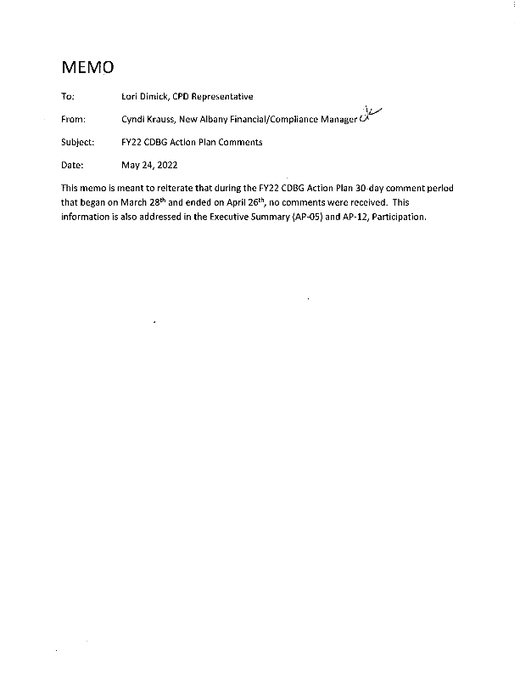

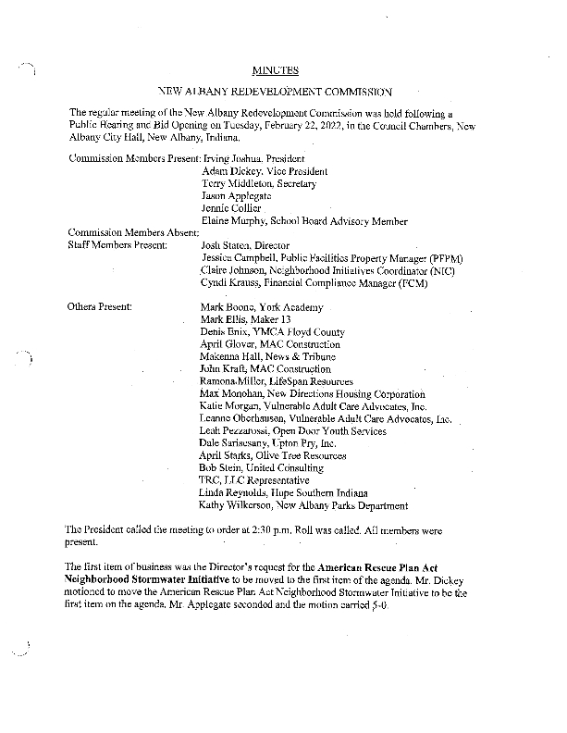

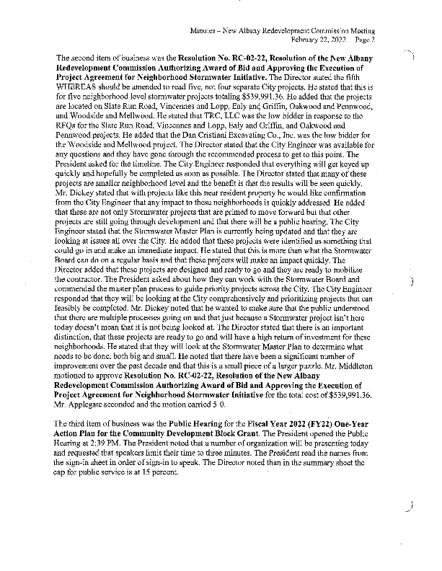

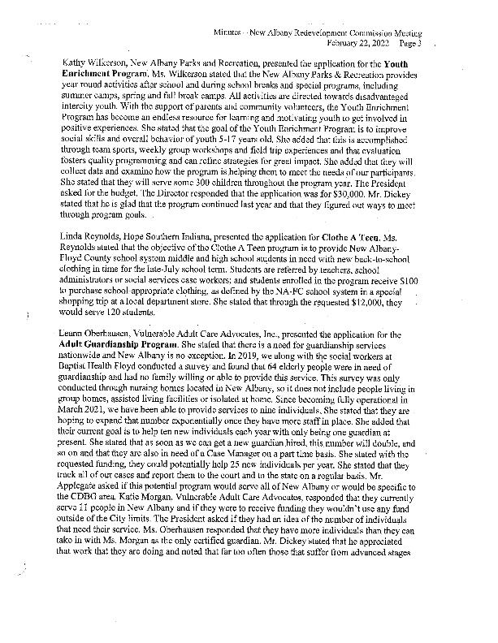

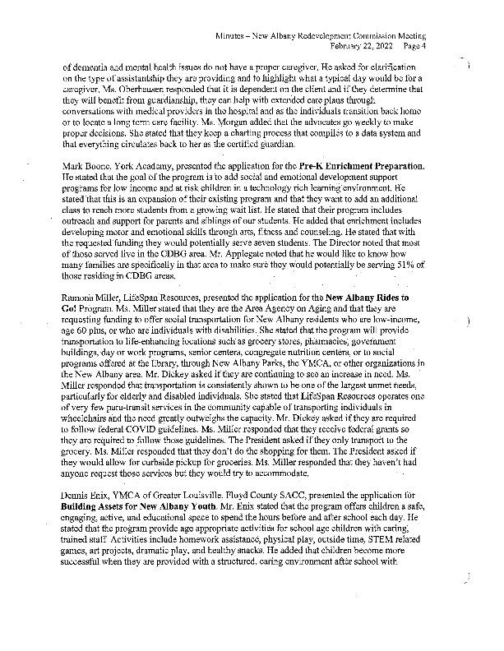

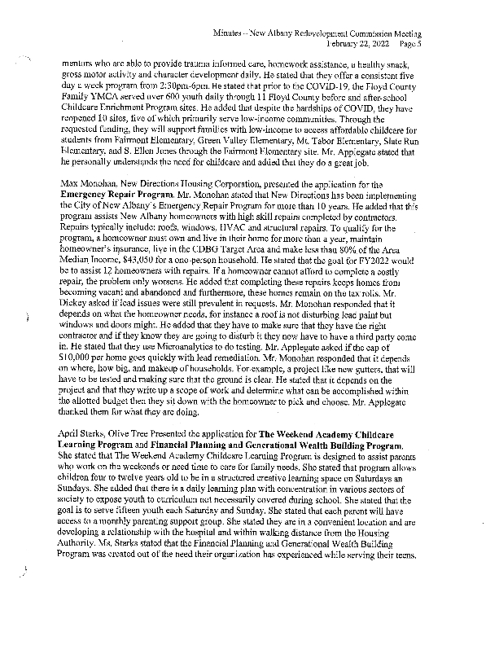

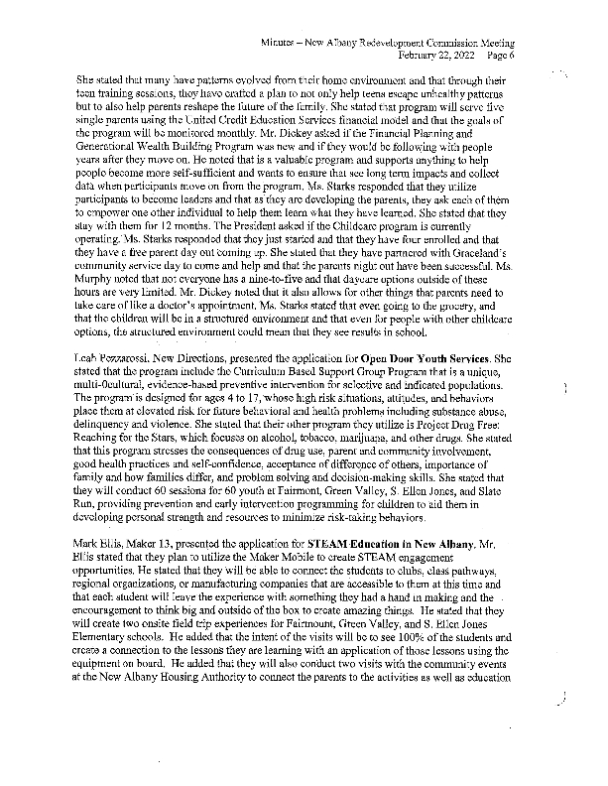

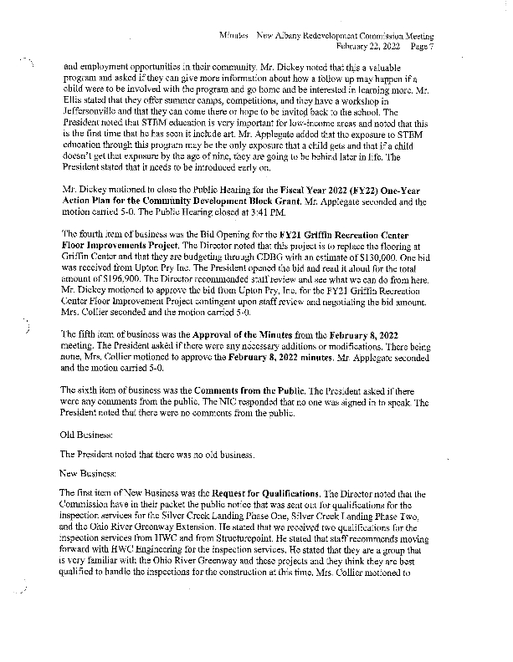

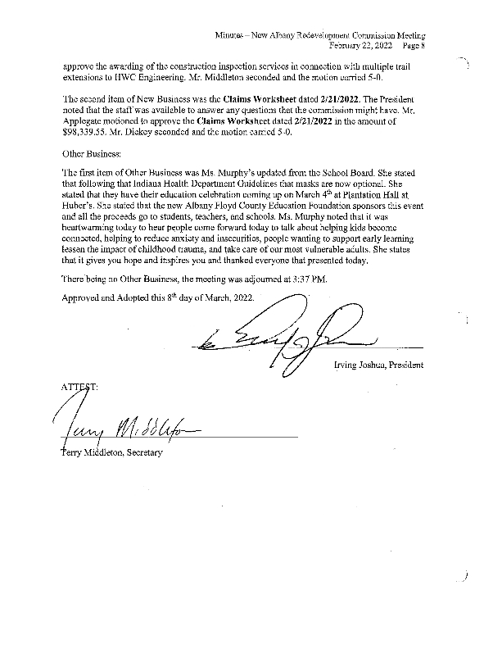

**Grantee Unique Appendices**

